Scientific THEORY vs. LAW QUIZ- ANSWER KEY

When a scientist makes a quick guess about something, it is called a scientific theory. *
True
False

After providing research to back the theory, a scientific theory becomes a scientific law. *
True
False

A scientific theory explains things that happen in nature. *
True
False

A scientific theory cannot be modified. *
True
False

The evidence and data supporting the movement of the Earth's outer layers over time (Plate Tectonics) is an example of a scientific ____________. *
Theory
Lawt

Scientific Laws often include a mathematical relationship observed in nature. *
True
False

Please indicate if the following statement describes a Scientific theory or scientific law: "Earth's average temperatures will continue to increase because of the deterioration of the ozone layer, allowing the sun's that were previously absorbed to reach Earth's surface." *
Scientific Theory
Scientific Law

Why? *

The following image is an example of a scientific ______________. *  Theory  Law | 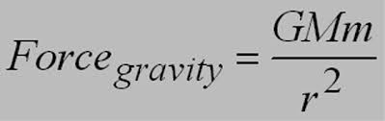

Scientific theories and scientific laws both describe observed events. *
True
Falsemi

